A Project report

on

**“Beat Electronics - Website”**

with

**Front End Engineerieng**

(CS186)

Submitted by

Akshat Chandel 2110990124



**Department of Computer Science & Engineering**

Chitkara University Institute of Engineering and Technology, Punjab

**Front page**

The provided HTML code is a basic webpage template for an electronic products retail website known as beat electronics. Here's a summary of the key components and functionality:

1. Document Structure:

- The code defines an HTML5 document structure with a typical `<head>` and `<body>` section.

- It includes a JavaScript section for interaction and functionality.

2. Header Section:

- The website's title, "Beat Electronic," is defined in the `<title>` tag.

- A favicon is set for the website.

- External CSS styles are linked using the `<link>` tag.

- The Boxicons library is imported for additional icons.

3. Body Content:

- The webpage content is organized into several sections, including the homepage, product types, reviews, our store, and a footer.

4. Homepage Section:

- The homepage introduces the website as a destination for electronic products.

- A call-to-action button "Shop Now" is provided, which scrolls down to the product types section when clicked.

5. Product Types Section:

- This section displays various product categories, such as Televisions, Refrigerators, Mobile Phones, etc., each with an image and a link to an individual product page.

- There are some HTML syntax issues in this section, including missing closing `<h3>` tags and an incorrect inline CSS property.

6. Review Section:

- Customer reviews are showcased, featuring names, star ratings, and comments.

- The star ratings are represented using Boxicons.

7. Our Store Section:

- This section displays images of the store.

8. Footer Section:

- The footer provides links to various social media platforms.

9. JavaScript Functionality:

- JavaScript is used to trigger an alert when the page loads.

- There are functions to handle "Shop Now" and "Login" button clicks.

- Event listeners are added to the "Shop Now" and "Login" buttons.

10. Issues and Considerations:

- There are some HTML syntax issues and missing CSS selectors that need to be addressed.

- The image sources should point to valid image files.

- The links in the footer should point to actual social media profiles.

- Individual HTML pages for the product categories (e.g., "television.html") need to be created to provide content for those sections.

Overall, the code provides a basic structure for an electronic product retail website with placeholders for content, styling, and interactivity. It would require additional development and content to make it a functional website.

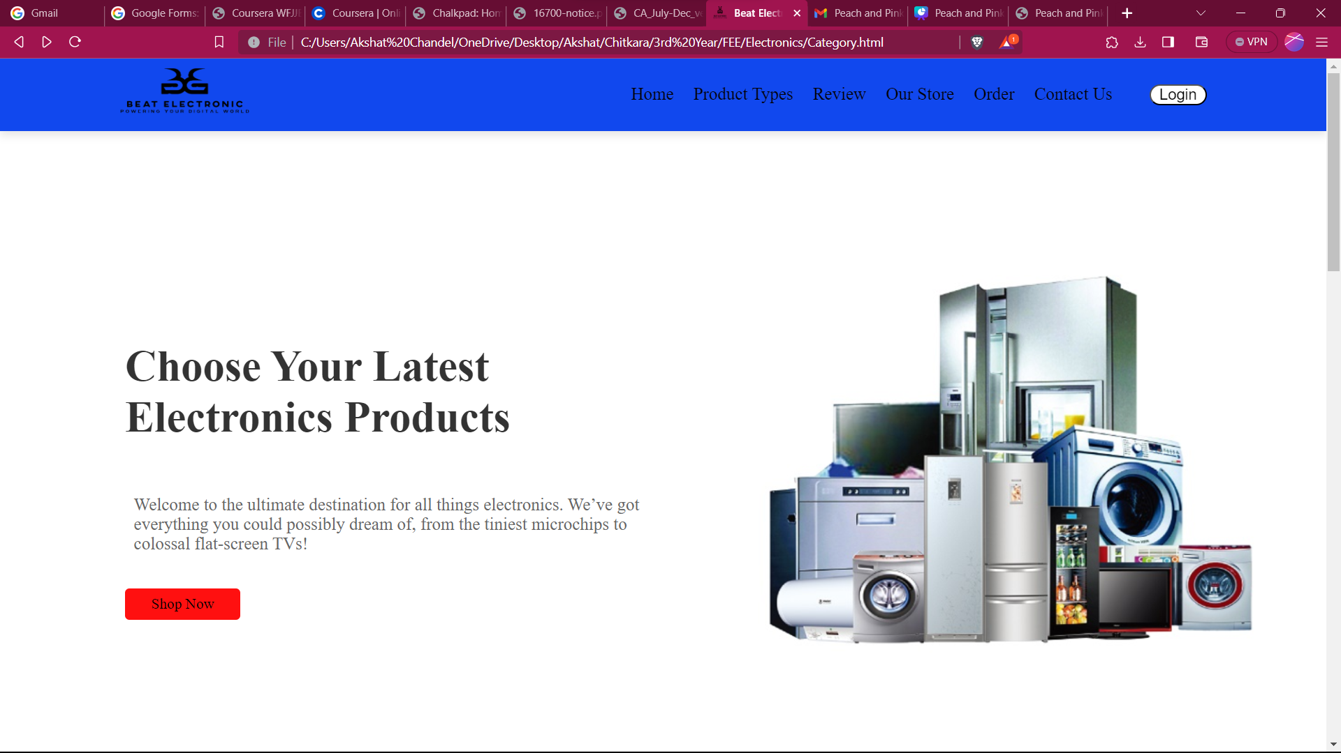

**Sub Category Page**

1. Document Structure:

- The document starts with the typical HTML structure, including the `<head>` and `<body>` sections.

2. Header Section:

- The page title is set as "Air Conditioner."

- A favicon is specified using the `<link>` tag.

- The header includes a logo that links to a "Category.html" page.

- There's a logo containing an icon (utensils) and the product category name "Air Conditioner."

- A menu icon is present (hamburger icon) for potential navigation options.

- The navigation bar includes links to "Home," "Brands," "Order," and "Socials."

3. Home Section (ID: "home"):

- This section introduces the product category "Air Conditioner."

- A brief description encourages users to shop for air conditioners and enjoy an upgraded home entertainment system.

- A "Shop Now" button is provided with a link to the "order" section.

4. Brands Section (ID: "brands"):

- This section presents a list of available brands for air conditioners.

- The heading "Brands Available" is provided.

- Each brand is displayed in a box with an image and a link to a specific page for that brand.

- The brands showcased include Whirlpool, Hitachi, Godrej, Hisense, LG, Samsung, and Haier.

5. Styling:

- External CSS styles are linked using the `<link>` tag with the reference to "style_fridge.css." The styling for this page is likely defined in that stylesheet.

6. Links and URLs:

- Links are set for the brand images, allowing users to navigate to specific brand pages for air conditioners.

- The "Shop Now" button links to the "order" section within the same page, likely for product ordering.

This HTML code provides a basic structure for an "Air Conditioner" product category webpage. Users can navigate to specific brand pages to explore air conditioner products. The code acts as a template and can be further developed to include detailed product information, pricing, and other relevant content.

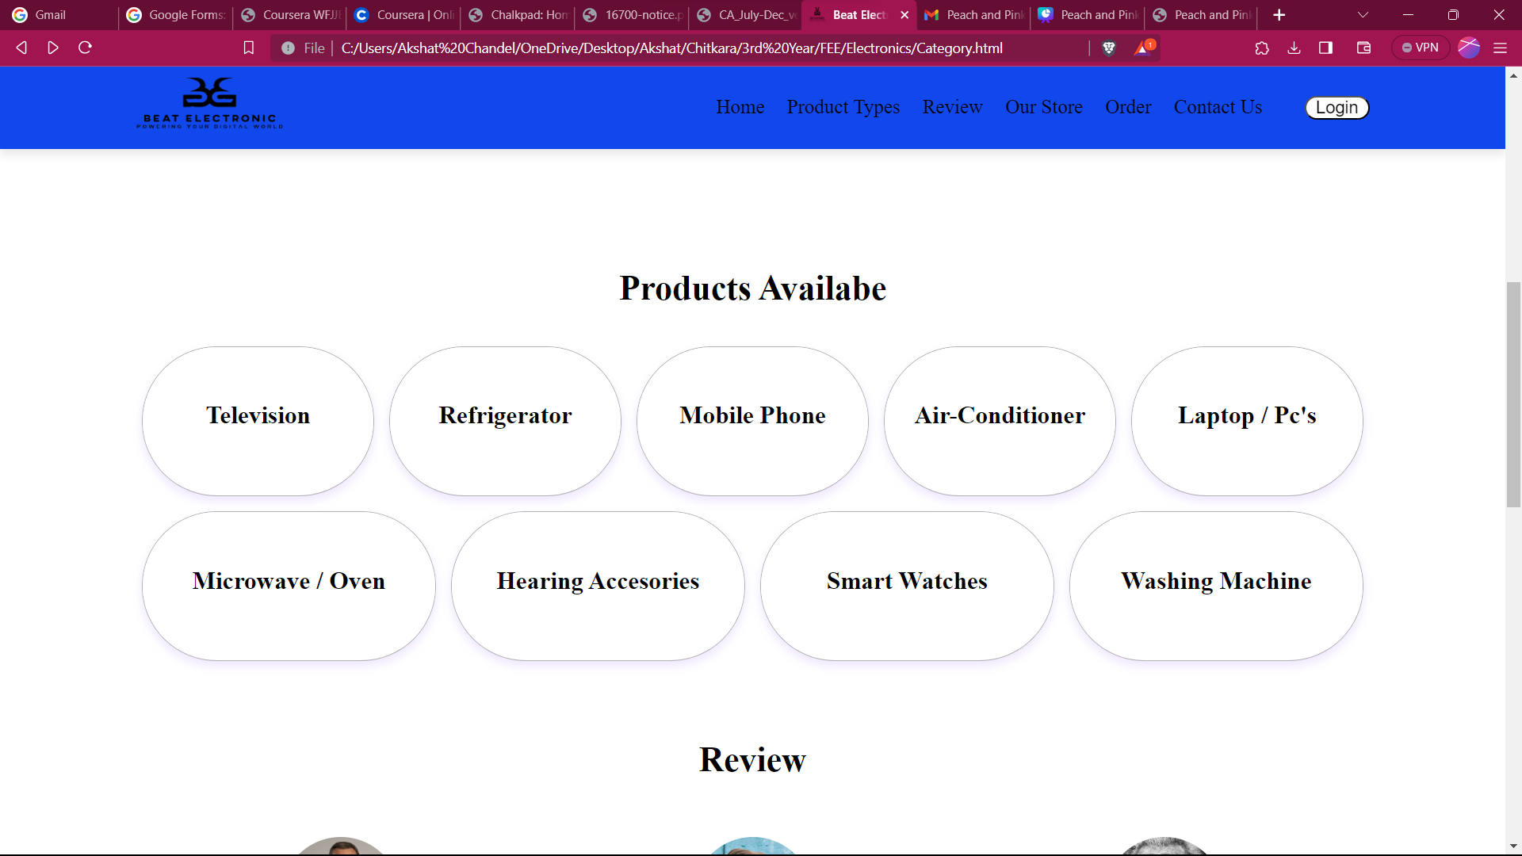

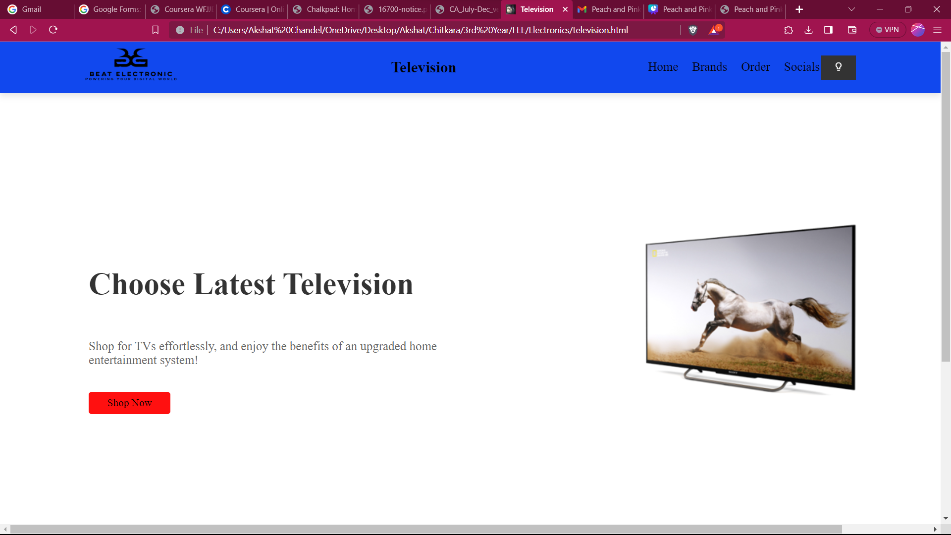

**Login and Sign In Page**

Synopsis of the HTML Code:

The provided HTML code represents a webpage for a login page on the "Beat Electronic" website. Here's a summary of the code's structure and content:

1. Document Structure:

- The code starts with the typical HTML structure, including the `<head>` and `<body>` sections.

2. Header Section:

- The page title is set as "Beat Electronic."

- A favicon is specified using the `<link>` tag.

- External CSS styles are linked using the `<link>` tag with a reference to "style_login_page.css."

- The header includes the website logo and a navigation bar with links to "Home," "Brands," "Order," and "Socials."

3. Login Section:

- This section is dedicated to the login functionality.

- It features a "Login" heading.

- A form is provided with the action attribute set to "Category.html," suggesting a redirection to the category page upon submission.

4. Form Elements:

- The form contains input fields for a username and password.

- Each input field is accompanied by an icon from the Boxicons library for the user and lock.

- A "Remember me" checkbox is included.

- There's also a link to "Forgot Password ?" that may lead to a password recovery page.

- A "Login" button is provided for submitting the form.

5. Registration Link:

- Below the login form, there is a link for users who don't have an account. It links to a "Register_here.html" page, presumably for user registration.

6. Styling and Icons:

- The page style is likely defined in the external "style_login_page.css" stylesheet.

- Icons from the Boxicons library are used to enhance the visual design.

This HTML code serves as a foundation for a login page on the "Beat Electronic" website. Users can enter their login credentials to access their accounts, and there is an option for password recovery and registration. The code can be further developed to handle actual user authentication and include more user-friendly features.

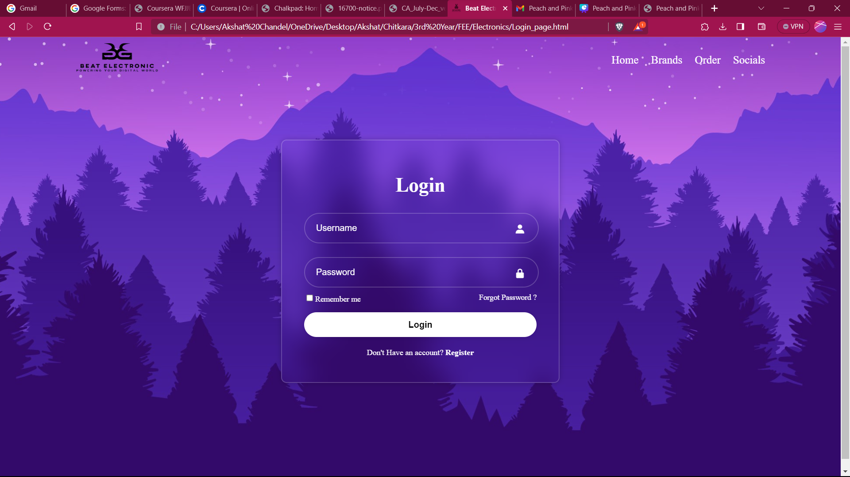

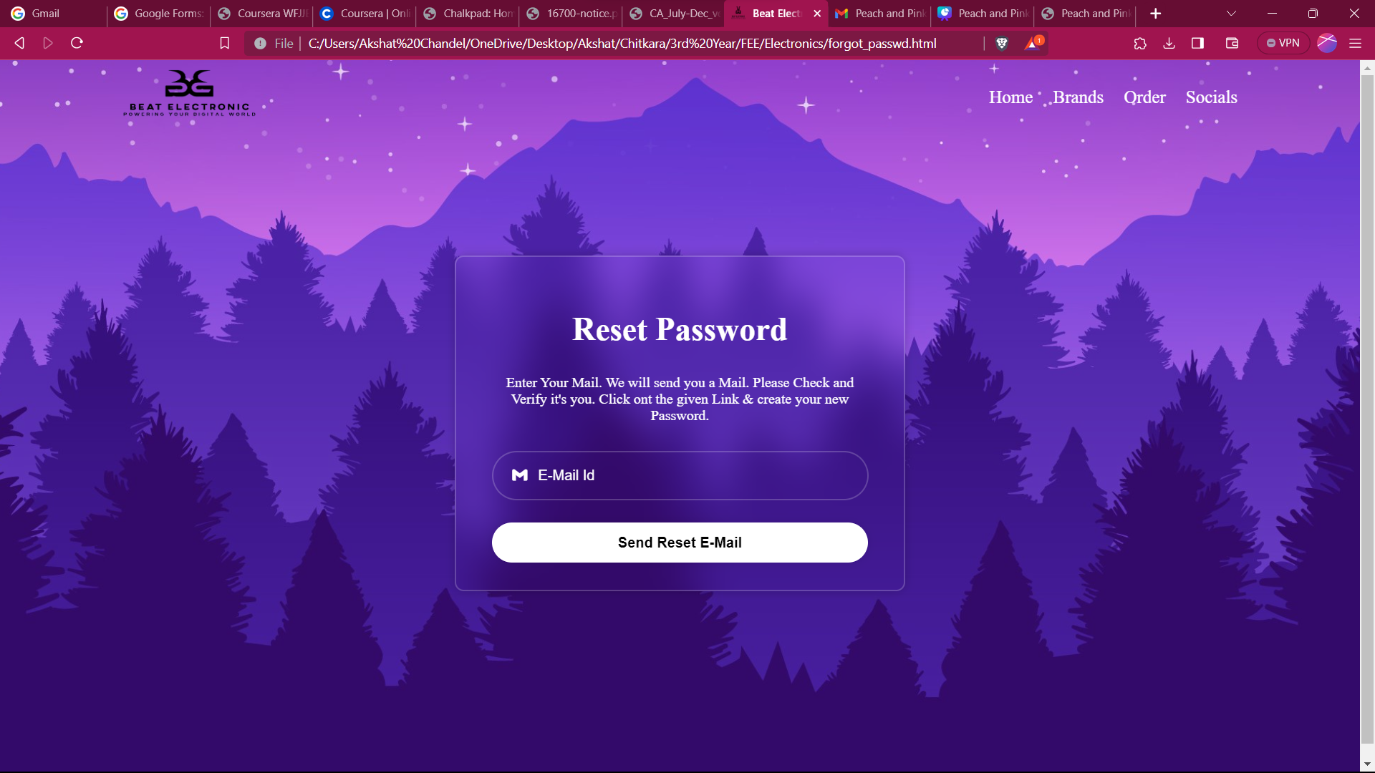

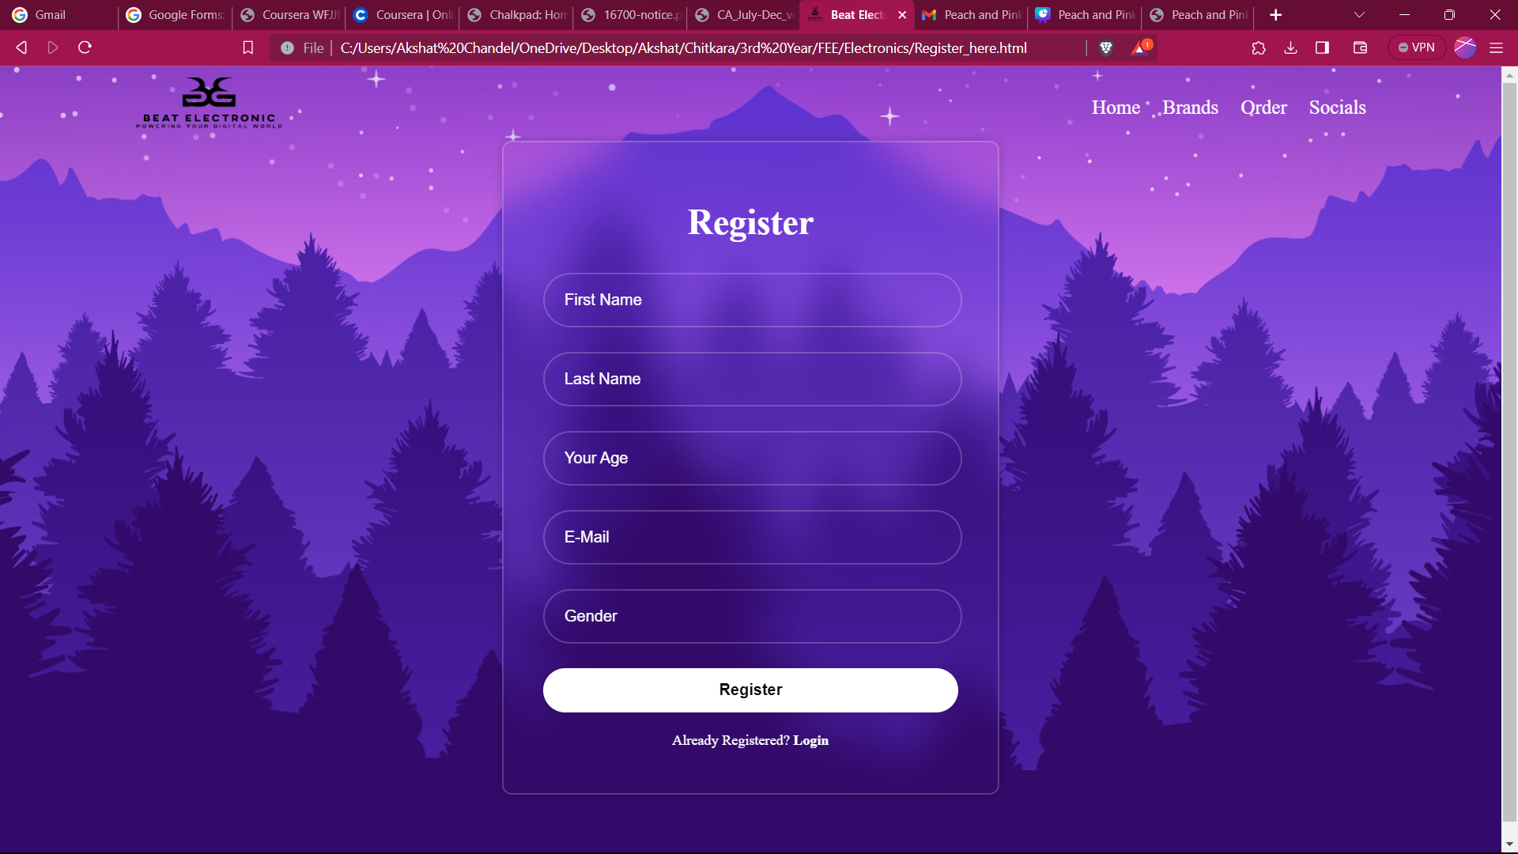

**Contact Us**

1. Document Structure:

- The document starts with the usual HTML structure, including the `<head>` and `<body>` sections.

2. Header Section:

- The page title is set as "Beat Electronic."

- A favicon is specified using the `<link>` tag.

- The header includes a logo image that links to a "Category.html" page. It also contains a navigation bar with links to "Home," "Product Types," "Our Store," and an "Order" section.

- There's a "Login" button linked to a "Login_page.html" page.

3. Contact Section:

- This section is dedicated to allowing users to contact the Beat Electronic team.

4. Content:

- A large image of the Beat Electronic logo is displayed.

- A heading "Contact our friendly team" is presented.

- A short description encourages users to reach out for assistance.

5. Contact Options:

- There are four contact options presented, each contained within a box:

- Feedback (✉️): This option links to a "feedback_form.html" page and encourages users to provide feedback. It includes an email address: `sales@beat_elec.com`.

- Chat to Support (💼): This option is for users to chat with support and provides an email address: `support@beat_elec.com`.

- Visit Us (🌐): This option suggests visiting the office HQ and provides a link to view the location on Google Maps.

- Call Us (📞): Users are given a phone number to call during specific hours: `+91-21641034135`.

6. Styling:

- Some inline CSS is used to style the icons and adjust their size.

7. Links and URLs:

- Links to various HTML pages and external resources (e.g., images, stylesheets) are specified. However, some links are left empty (`<a href="">`), which should be updated to point to the correct URLs.

8. Synopsis:

- The HTML code serves as a foundation for a contact page on the Beat Electronic website.

- It provides various contact options for users, encouraging them to provide feedback, chat with support, visit the office, or call for assistance.

- To make this page fully functional, the empty links need to be updated with appropriate URLs, and the associated HTML pages should be created for feedback forms and other content.

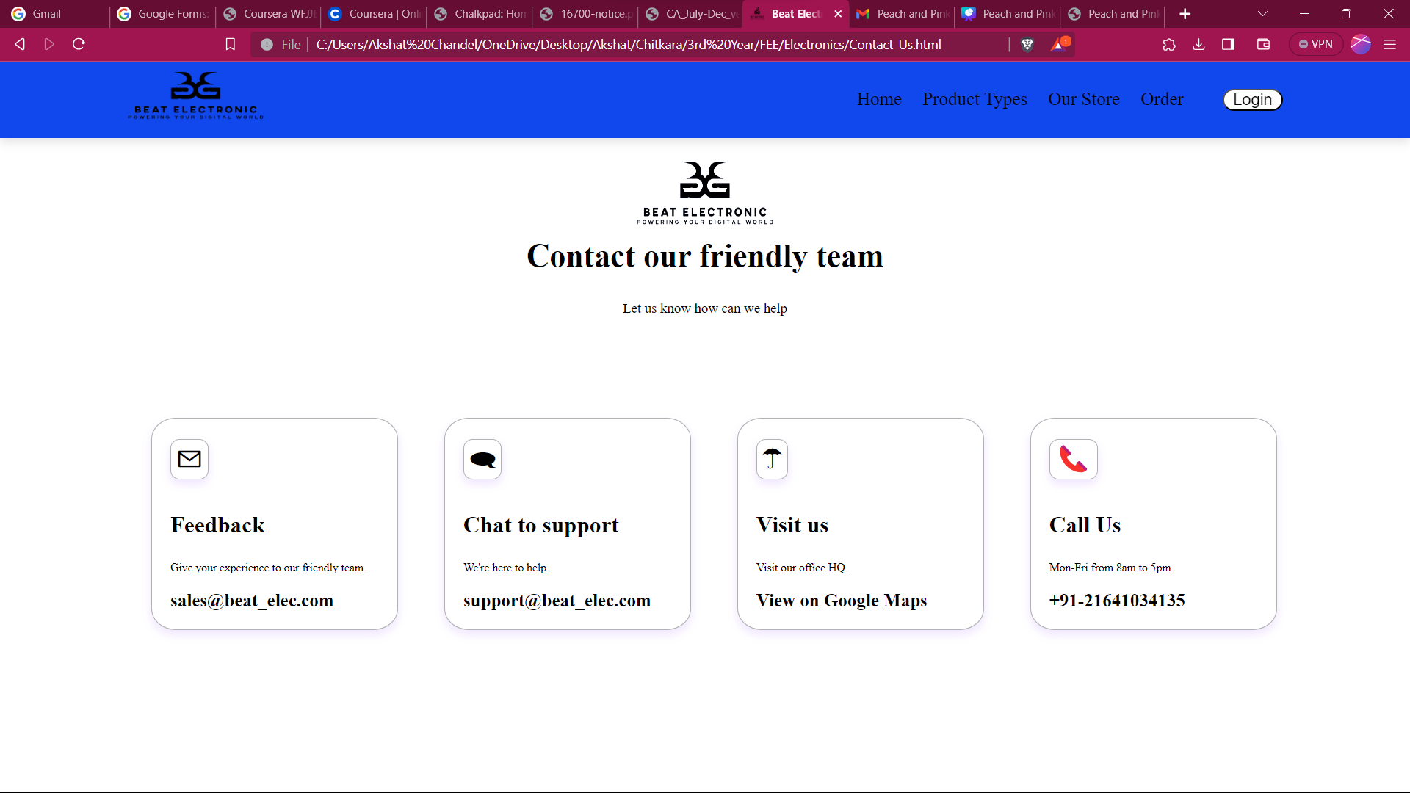

**FeedBack Page**

Synopsis of the HTML Code:

The provided HTML code represents a webpage for a feedback page on the "Beat Electronic" website. Here's an overview of the code's structure and content:

1. Document Structure:

- The code follows a standard HTML document structure with `<head>` and `<body>` sections.

2. Header Section:

- The webpage title is set as "Beat Electronic."

- A favicon (website icon) is specified.

- External CSS styles are linked from "style_feedback_page.css."

- The header includes the website logo and a navigation bar with links to "Home," "Product Types," "Our Store," "Order," and a "Login" button that links to the login page.

3. Feedback Section:

- This section is dedicated to collecting user feedback.

- It starts with a "Feedback" heading and a descriptive paragraph encouraging users to provide feedback to help improve the website.

4. Contact Information:

- A container with contact information is provided. This includes:

- An address with an icon.

- A phone number with an icon.

- An email address with an icon.

5. Feedback Form:

- A contact form is included to collect feedback. It contains:

- A "Send Feedback" heading.

- Input fields for the user's full name and email address.

- A textarea for entering feedback.

- A "Submit Feedback" button for submitting the feedback.

6. Styling and Icons:

- The visual style of the page is likely defined in an external "style_feedback_page.css" stylesheet.

- Icons from the Boxicons library are used to enhance the design.

This HTML code provides the structure for a feedback page where users can share their feedback with "Beat Electronic." The page also includes contact information for users who might prefer to reach out directly. To fully implement the feedback functionality, the form should be connected to a backend system that can process and store user feedback.

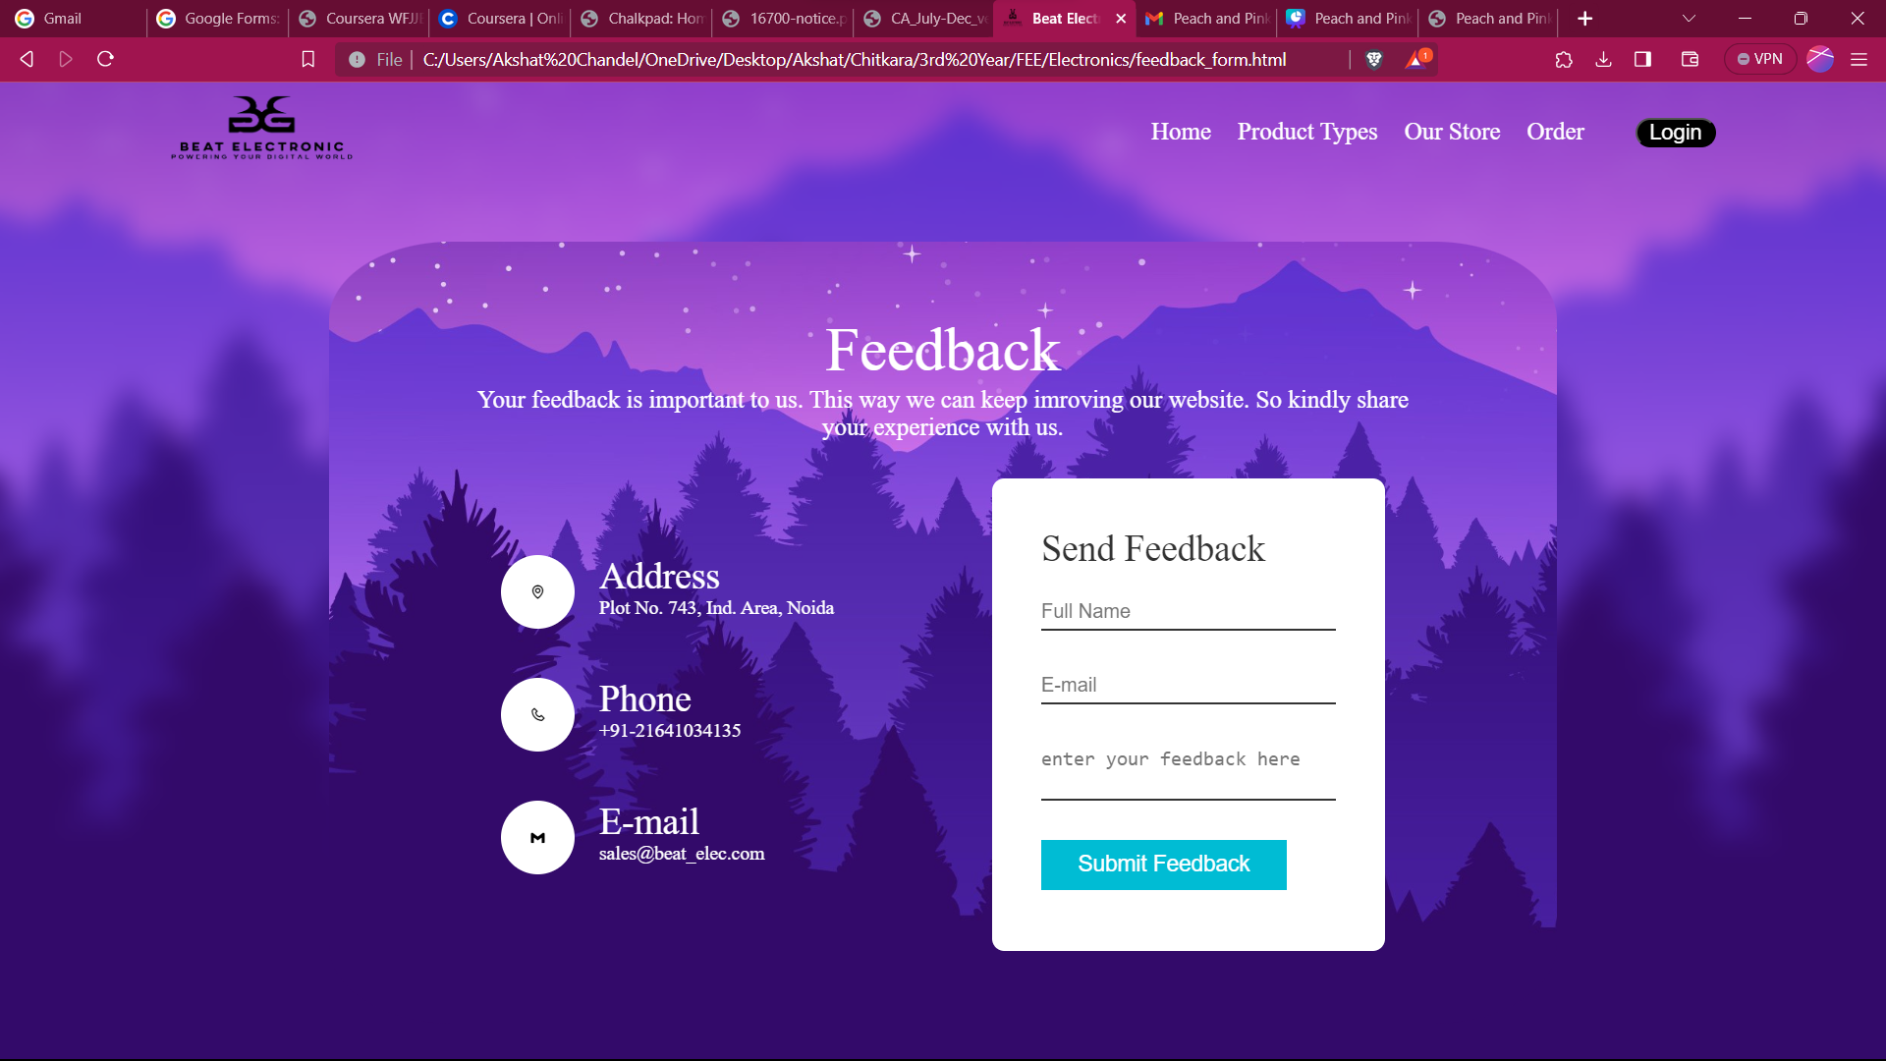

**Add To Cart Page**

Synopsis of the HTML Code:

The provided HTML code represents a webpage for "Samsung Refrigerator." Here's an overview of the code's structure and content:

1. Document Structure:

- The code follows a standard HTML document structure with `<head>` and `<body>` sections.

2. Header Section:

- The webpage title is set as "Samsung Refrigerator."

- A favicon (website icon) is specified.

- External CSS styles are linked from "style_fridge_lg.css."

- The header includes the website logo with the Samsung Refrigerator brand name, a navigation bar with links to "Home," "Available Refrigerators," "Order," and "Socials."

3. Home Section:

- This section features a promotional banner with a title, description, and a "Shop Now" button.

- It includes an image of the Samsung Refrigerator logo.

4. Main Section:

- The main section contains a list of available Samsung refrigerators.

- A filter dropdown is provided to filter refrigerators by price category.

- Each refrigerator listing includes an image, product name, price (with a discounted price), and features.

- An "Add to Cart" button is included for each product, and clicking it increments a counter.

5. Footer:

- The footer section provides a contact email address.

6. JavaScript:

- A JavaScript script is included at the end of the document to handle the "Add to Cart" functionality. It increments a counter when the button is clicked.

This HTML code presents a webpage for shopping Samsung refrigerators with product listings, pricing, and the ability to add products to a cart. Users can filter products by price category, and the site tracks the number of products added to the cart. The contact email address is provided in the footer.

